**“CREDIT CARD FRAUD DETECTION”**

# A

## Project Report

*Submitted to the*

## Bikaner Technical University, Bikaner

*In partial fulfillment of the requirement for the award of the Degree of*

***Bachelor of Technology***

*In*

***Computer Science & Engineering***



## Guided by: Submitted by:

Mr.Vishnu Prakash Sharma Bajrang lal (18EEACS015)

(Assistant Professor) David (18EEACS018)

Ritik Jain (18EEACS071)

## Department of Computer Science & Engineering

## Engineering College, Ajmer

**Bikaner Technical Universit**y

## 2021-22

**CANDIDATE’S DECLARATION**

We hereby declare that the project work entitled, **“**CREDIT CARD FRAUD DETECTION**”** submitted in partial fulfillment of the requirement for the award of degree of “Bachelor of Technology” in Computer Science & Engineering, Bikaner Technical University, Bikaner, is an authentic record of our own work carried out during VIII semester under the Guidance of **Mr. Vishnu Prakash Sharma**, **Assistant Professor** Govt. Engineering College Ajmer.

**Bajrang lal chaudhary** (18EEACS015)

**David** (18EEACS018)

**Ritik Jain** (18EEACS071)

Computer Science & Engineering,

Engineering College, Ajmer

Engineering College Ajmer

**Department of Computer Science & Engineering**

**CERTIFICATE**

This is to certify that following students of VIII Semester, B. Tech. (Computer Science & Engineering) 2021-22 have successfully completed the project titled “Credit Card Fraud Detection**”** in partial fulfillment for the award of the degree of Bachelor of Technology under Bikaner Technical University, Bikaner.

1. **Mr. Bajrang Lal Chaudhary** (18EEACS015)
2. **Mr. David** (18EEACS018)
3. **Mr. Ritik Jain** (18EEACS071)

Date : 16-06-2022

|  |  |  |
| --- | --- | --- |
| **Mr. Vishnu Prakash Sharma** | **Mr. Deepak Gupta** | **Dr. Jyoti Gajrani** |
| **(Project Guide)** | **(Project Co-ordinator)** | **(Head, CSE)** |

# ACKNOWLEDGEMENT

The project report on “Credit Card Fraud Detection” is outcome of guidance, moral support and devotion bestowed on us throughout our work. For this, we acknowledge and express our profound sense of gratitude and thanks to everybody who have been a source of inspiration during the project preparation.

We offer our sincere phrases of thanks with to our Project Guide, **Mr. Vishnu Prakash Sharma** without whose support and guidance it would not have been possible for this Project to have materialized and taken a concrete shape.

I would also like to express our gratitude to our Project Coordinator **Mr. Deepak Gupta**, to provide us a better facility to enhance our practical knowledge.

We are thankful to **Dr. Jyoti Gajrani** (HOD, CSE), Engineering College, Ajmer.

At last but not the least, I am thankful to all our colleagues and other staff members, who helped us directly or indirectly in the Project work.

Bajrang Lal (18EEACS015)

David (18EEACS018)

Ritik Jain (18EEACS071)

**Table of Contents**

|  |
| --- |
| Candidate Declaration...........................................................................................................… ii  Certificate ...........................................................................................................................…. iii  Acknowledgement...............................................................................................................…. iv  Table of content .................................................................................................................….. v  List of Figures …................................................................................................................…..vi  Abstract...............................................................................................................................… vii  Chapter 1: Introduction …… ............................................................................………….......01   * 1. Problem Satement……............................................................................………...01   2. Motivation……………………..……………………………………………...….02   3. Organisation of Report…………………………………………………….…..…02   Chapter 2: Literature Survey……………….......................................................…………….03  2.1 Present Work……………………………………………………………………..03  2.2 Tools and Technologies.................................................................................……04  Chapter 3: System Analysis………….…………………………………………..…………..06   * 1. System Requirement…….............................................................................….…06   2. Block Diagram…………………………………………………………………...07   3. Data Flow Diagram……………………...…………………………………..…...08   Chapter 4: System Design………..……………………………………………….………….09  4.1 Algorithm……................................................................................................…...09  4.2 Important Library/API’s……………………………………………. .…....…….10  4.3 Dataset Processing………………………………………………………..……...13  Chapter 5: Implementation…………..…………………….………………………………...16  5.1 Screenshots of Input and Output...............................................................……...16  Chapter 6: Result Analysis and Discussion………………………………..………………..19  Chapter 7: Conclusion and Future Scope………..…….…………..…………………..……20  Appendix ….......................................................................................................................….21  Bibliography …..................................................................................................................…24 |

**List of Figures**

Fig. 1.1 Increasing credit Card frauds over the years………………………………...…02

Fig. 2.1 Self-Organizing Maps……………………………………………………….…04

Fig 3.2.1 Working Model…..………………………..……………………………….…..07

Fig 3.2.2 Algo Output…...………………………………………………………………..07

Fig 3.3.1 Fraud Detection diagram……………………………………………………….08

Fig 3.3.2 Neuron Diagram ………………...……………………………………………..08

Fig 4.2 SOM Heatmap………………………………………………………………….10

Fig 4.3 Detected Frauds………………………………………………………………..11

Fig 4.4 Dataset…………………………………………………………………………14

Fig 5.1 Output after SOM…………………………………………………………… . 16

Fig 5.2 Output 1………………………………………………………………………..16

Fig 5.3 Output 2………………………………………………………………………..17

Fig 5.4 Output 3………………………………………………………………………..17

Fig 5.5 Output 4………………………………………………………………………. .18

Fig 5.6 Output 5…………………………………………………………………..……18

Fig 5.7 Output 6………………………………………………………………………..18

Fig 7.1 Coding Screenshot……………………………………………………………..18

Fig 7.2 Coding Screenshot……………………………………………………………..18

**ABSTRACT**

It is vital that credit card companies are able to identify fraudulent credit card transactions so that customers are not charged for items that they did not purchase. Such problems can be tackled with Data Science and its importance, along with Machine Learning, cannot be overstated. This project intends to illustrate the modelling of a data set using machine learning with Credit Card Fraud Detection. The Credit Card Fraud Detection Problem includes modelling past credit card transactions with the data of the ones that turned out to be fraud. This model is then used to recognize whether a new transaction is fraudulent or not. Our objective here is to detect 100% of the fraudulent transactions while minimizing the incorrect fraud classifications. Credit Card Fraud Detection is a typical sample of classification. In this process, we have focused on analysing and pre-processing data sets as well as the deployment of multiple anomaly detection algorithms such as SOM and ANN on the PCA transformed Credit Card Transaction data.

**Chapter 1**

**Introduction**

Today use of Credit Card even in developing countries has become a common scenario. People use it to shop, pay bills and for online transactions. But with increase in number of Credit Card users, the cases of fraud in Credit Card have also been on rise. Credit Card related frauds cause globally a loss of billions of dollars. Fraud can be classified as any activity with the intent of deception to obtain financial gain by any manner without the knowledge of the cardholder and the issuer bank. Credit Card fraud can be done in numerous ways. By lost or stolen cards, by producing fake or counterfeit cards, by cloning the original site, by erasing or modifying the magnetic strip present at the card which contains the user’s information, by phishing, by skimming or by stealing data from a merchant’s side.

## Problem Statement:

The Credit Card Fraud Detection Problem includes modeling past credit card transactions with the knowledge of the ones that turned out to be fraud. This model is then used to identify whether a new transaction is fraudulent or not. Our aim here is to detect 100% of the fraudulent transactions while minimizing the incorrect fraud classifications.

The credit card fraud detection features use user behaviour and location scanning to check for unusual patterns. These patterns include user characteristics such as user spending patterns as well as usual user geographic locations to verify his identity. If any unusual pattern is detected, the system requires revivification. The system analyses user credit card data for various characteristics. These characteristics include user country, usual spending procedures. Based upon previous data of that user the system recognizes unusual patterns in the payment

procedure. So now the system may require the user to login again or even block the user for more than 3 invalid attempts.

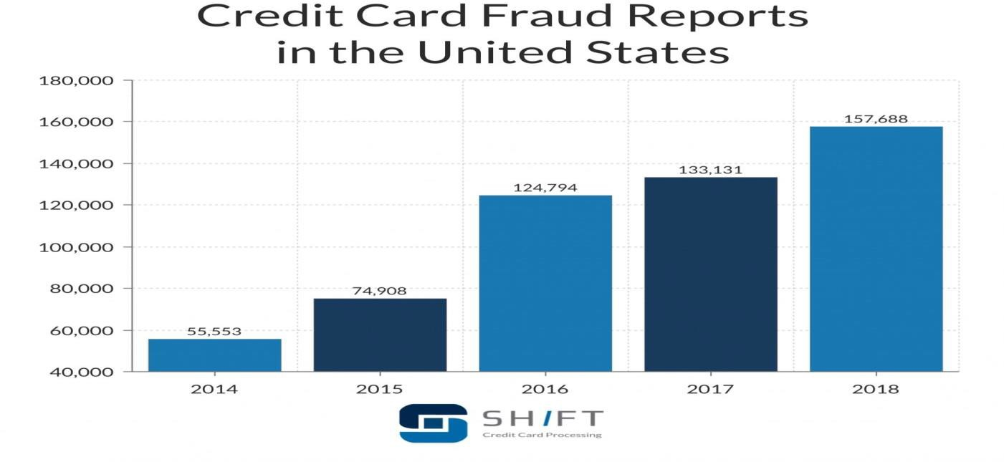

Fig 1.1 Increasing credit card frauds over the years

## Motivation :

Fraud has been increasing drastically with the progression of state-of-art technology and worldwide communication. With continued advancement in fraudulent strategies it is important to develop effective models to combat these frauds in their initial stage only, before they can take to completion. This is a very relevant problem that demands the attention of communities such as machine learning and data science where the solution to this problem can be automated.

## Organisation of Report :

Credit card fraud detection has been a keen area of research for the researchers for years and will be an intriguing area of research in the coming future. The main goal of this project is to help merchants, financial services consultancies and payment service providers distinguish fraudsters from customers. It also gathers information and analyses highly-detailed behavioural patterns such as browsing patterns, keyboard preferences and screen tilt.

## Chapter 2

## Literature & Survey

* 1. **Present Work :**

In earlier studies, many approaches have been proposed to bring solutions to detect fraud from supervised approaches, unsupervised approaches to hybrid ones; which makes it a must to learn the technologies associated in credit card frauds detection and to have a clear understanding of the types of credit card fraud. As time progressed fraud patterns evolved introducing new forms of fraud making it a keen area of interest for researchers. During the project we went through many research papers of which we primarily focused on Research Gate published conference paper “Real-time Credit Card Fraud Detection Using Machine Learning “. We also went through popular computer vision websites such as [www.towardsdatascience.com,](http://www.towardsdatascience.com/) [www.rubikscode.net](http://www.rubikscode.net/) and read documents related to Self Organizing Maps (SOM) and watched various videos so as to understand the approaches to solve the problem. The main aim in referring the websites was to understand the techniques and select an appropriate and viable method for the project.

While searching for a dataset we went through many websites such as [www.archive.ics.uci.edu](http://www.archive.ics.uci.edu/) and other dataset websites. We choose Credit Approval Dataset due to its contents i.e. it contains about 15 features divided into 3 classes (integer, real and categorical) which would surely help in training the model to achieve a high accuracy. This dataset was very interesting because there was a good mix of attributes -- continuous, nominal with small numbers of values, and nominal with larger numbers of values. There were also a few missing values. For building the neural network used keras with TensorFlow as a backend to build the network. The network is a 3-layer network with 11 input nodes 3 nodes in middle layer and one node in Output layer. Visualization of the results is done using Matplotlib

## Tools & Technologies :

* + 1. **Self-Organizing Feature Maps (SOM):**

**SOM** was introduced by Finnish professor Teuvo Korhonen in the 1980s is sometimes called a **Korhonen map.** Each data point in the data set recognizes themselves by competing for representation. SOM mapping steps starts from initializing the weight vectors. From there a sample vector is selected randomly and the map of weight vectors is searched to find which weight best represents that sample. Each weight vector has neighbouring weights that are close to it. The weight that is chosen is rewarded by being able to become more like that randomly selected sample vector. The neighbours of that weight are also rewarded by being able to become more like the chosen sample vector. This allows the map to grow and form different shapes. Most generally, they form square/rectangular/hexagonal/L shapes in 2D feature space.

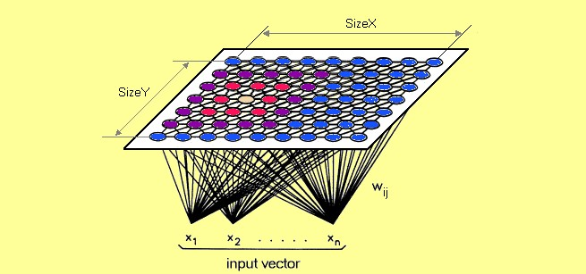

Fig 2.1 Self-Organizing Feature Maps

## Artificial Neural Network (ANN):

It combines the thinking power of human brain with computational power of machine. It makes use of neurons as the deciding sites and the edges between neurons to calculate the contribution of each neuron in the previous layer in the decision and result at the current neuron. It is based on pattern recognition. Previous year’s data is fed into the network and then based upon that

data it recognises a new incoming transaction to be a fraud or genuine one. Its training can either be supervised i.e. the outcome is already known for a given transaction and the expected output is compared with actual to train the system or it can be unsupervised where we have no actual results to compare it with and thus are not sure about the results.

## Django:

Django is a high-level Python Web framework that encourages rapid development and clean, pragmatic design. Built by experienced developers, it takes care of much of the hassle of Web development, so you can focus on writing your app without needing to reinvent the wheel. It’s free and open source. Django also helps developers avoid many common security mistakes by providing a framework that has been engineered to "do the right things" to protect the website automatically.

**Chapter 3**

**System Analysis**

## 3.1 Requirements:

**3.1.1 Functional Requirements:**

* + - * The system should train the parameters based on the testing dataset provided.
      * System shall recognize the type of transaction (legitimate or fraud) from the testing dataset and place them in the appropriate class.
      * The system shall display the predicted result and the actual result for the unknown sample provided.

## 3.1.2 Non-Functional Requirements:

* + - * Performance: The designed system will recognize and classify the transaction in its appropriate class with an accuracy close to 94%.
      * Reliability: The system should work for all type of values in the dataset.
      * Functionality: The system will deliver the functional requirements mentioned in the documents.

## 3.1.3 Software Requirements:

* + - 1. Python 3.x
      2. Sklearn
      3. Matplotlib
      4. Pandas
      5. NumPy
      6. PyCharm

## 3.1.4 Hardware Requirements:

* + - 1. Intel core i3 +
      2. GPU like Nvidia GeForce
      3. 4 GB + RAM

## 3.2 Block Diagrams :

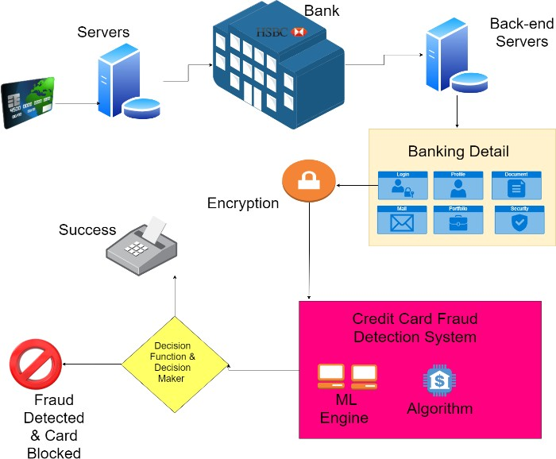

Fig 3.2.1 Working model

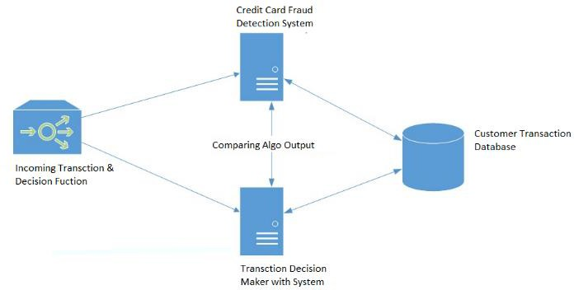

Fig 3.2.2 Algo output

## 3.3 Data Flow Diagrams :

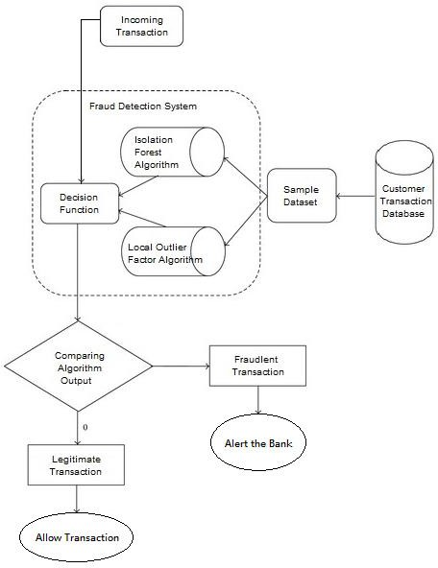

Fig 3.3.1 Fraud Detection diagram

Fig 3.3.2 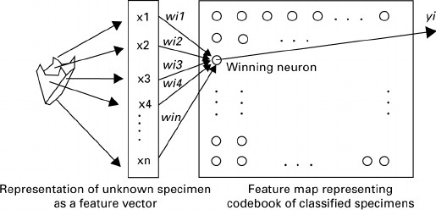Neuron diagram

**Chapter 4**

**System Design**

**4.1 Algorithm :**

1. Each node’s weights are initialized.
2. A vector is chosen at random from the set of training data.
3. Every node is examined to calculate which one’s weights are most like the input vector. The winning node is commonly known as the **Best Matching Unit** (BMU).
4. Then the neighbourhood of the BMU is calculated. The amount of neighbours decreases over time.
5. The winning weight is rewarded with becoming more like the sample vector. The neighbours also become more like the sample vector. The closer a node is to the BMU, the more its weights get altered and the farther away the neighbour is from the BMU, the less it learns.
6. Repeat step 2 for N iterations.

**Best Matching Unit** is a technique which calculates the distance from each weight to the sample vector, by running through all weight vectors. The weight with the shortest distance is the winner. There are numerous ways to determine the distance, however, the most commonly used method is the **Euclidean Distance***,* and that’s what is used in the following implementation*.*

**4.2 Important Library / APIs :**

## Model Selection

We have used a Hybrid Deep Learning approach, in which we first used Unsupervised learning to find potential frauds using Self Organizing Maps and then we use the Supervised Learning approach using Artificial Neural Network with O/p from SOM as target variable of the network. Thus, improving the accuracy.

## 4.2.1 Self-Organizing Maps:

We have chosen a 10x10 grid to visualize the results. We have used MiniSom which a library used to build an SOM.

*from minisom import MiniSom*

*som = MiniSom(x = 10, y = 10, input_len = 15, sigma = 1.0, learning_rate = 0.5) som.random_weights_init(X)*

*som.train_random(data = X, num_iteration = 100)*

*Visualization:*

*from pylab import bone, pcolor, colorbar, plot, show bone()*

*pcolor(som.distance_map().T) colorbar()*

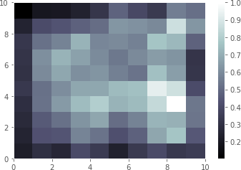

Fig 4.2 SOM Heatmap

The outlier blocks with co-ordinate (8,3) and (7,4) and s represents a node with customers who do not follow the general rules .We can find the frauds as follows:

*# Finding the frauds mappings = som.win_map(X)*

*frauds = np.concatenate((mappings[(8,3)], mappings[(7,4)]), axis = 0)*

*frauds = sc.inverse_transform(frauds)*

*print(frauds)*

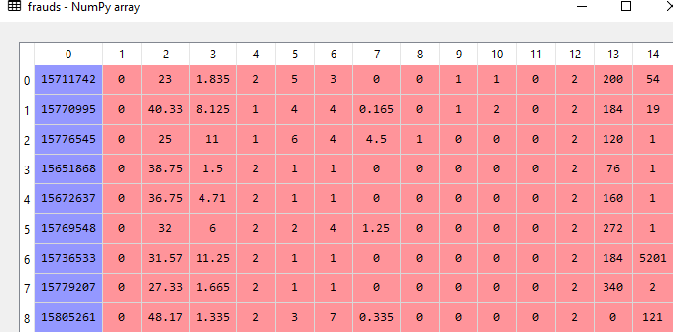

Fig 4.3 Detected frauds

## 4.2.2 Artificial Neural Network(ANN):

Now, we create a Network with three layers.

First layer with 15 input nodes and apply **Relu** (Rectified Linear Unit) activation function to the nodes. The second layer has 2 nodes with Relu as activation function and third layer with one node tells the probability of the customer being fraud. Sigmoid activation function is applied which is best for output layer.

The model is build using Keras with Tensorflow as a backend.

Implementation:

*from keras.models import Sequential from keras.layers import Dense*

*# Initialising the ANN classifier = Sequential()*

*# Adding the input layer and the first hidden layer*

*classifier.add(Dense(units = 2, kernel_initializer = 'uniform', activation = 'relu', input_dim = 15))*

*# Adding the output layer*

*classifier.add(Dense(units = 1, kernel_initializer = 'uniform', activation = 'sigmoid'))*

*# Compiling the ANN*

*classifier.compile(optimizer = 'adam', loss = 'binary_crossentropy', metrics = ['accuracy'])*

*# Fitting the ANN to the Training set*

*classifier.fit(customers, is_fraud, batch_size = 1, epochs = 5)*

**4.3 Dataset Processing:**

**4.3.1 Data Preparation:**

We will use the UCI Machine Learning Repository for credit card fraud dataset. After extensive research, we have selected the Credit approval dataset.

Diagnostic: [http://archive.ics.uci.edu/ml/datasets/Credit+Approval](http://archive.ics.uci.edu/ml/datasets/Credit%2BApproval) This data concerns credit card applications; good mix of attributes. Dataset Information:

This file concerns credit card applications. This dataset is interesting because there is a good mix of attributes -- continuous, nominal with small numbers of values, and nominal with larger numbers of values. There are also a few missing values.

Attribute Information:

**ATTRIBUTE NAMES HAVE BEEN MASKED FOR DATA CONFIDENTIALITY**

|  |  |
| --- | --- |
| A1 | b, a |
| A2 | continuous |
| A3 | continuous |
| A4 | u,y,l,t |
| A5 | g,p,gg |
| A6 | c,d,cc,i,j,k,m,r,q,w,x,e,aa,ff |
| A7 | v,h,bb,j,n,z,dd,ff,o |
| A8 | continuous |
| A9 | t,f |
| A10 | t,f |

|  |  |
| --- | --- |
| A11 | continuous |
| A12 | t,f |
| A13 | g,p,s |
| A14 | continuous |
| A15 | continuous |
| A16 | +, - (class attribute) |

## 4.3.2 Data Exploration:

We will be using ***Spyder*** to work on this dataset. We will first go with importing the necessary libraries and our dataset to PyCharm:

*import numpy as np*

*import matplotlib.pyplot as plt from matplotlib import style import pandas as pd*

*# Importing the dataset*

*dataset = pd.read_csv('Credit_Card_Applications.csv')*

*X = dataset.iloc[:, :-1].values y = dataset.iloc[:, -1].values print(dataset.head())*

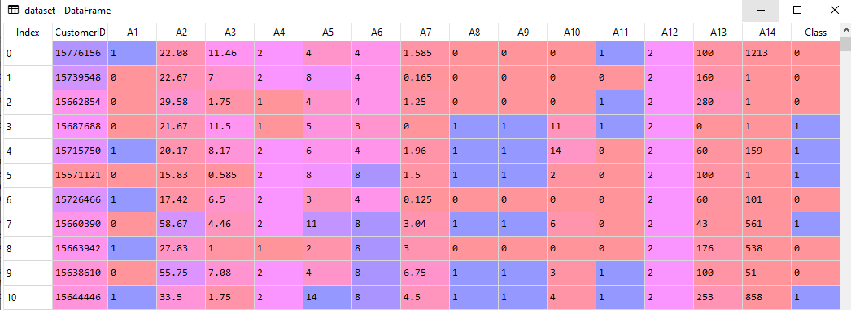

Fig 4.4 Dataset

## 4.3.3 Feature Scaling

Most of the times, your dataset will contain features highly varying in magnitudes, units and range. We need to bring all features to the same level of magnitudes. This can be achieved by scaling. This means that you’re transforming your data so that it fits within a specific scale, like 0–100 or 0–1.

For this, we use MinMaxScaler, to bring all values between 0 and 1

*from sklearn.preprocessing import MinMaxScaler sc = MinMaxScaler(feature_range = (0, 1))*

*X = sc.fit_transform(X)*

**Chapter 5**

**Implementation**

## 5.1 Screen shots of Input / Output Screen :

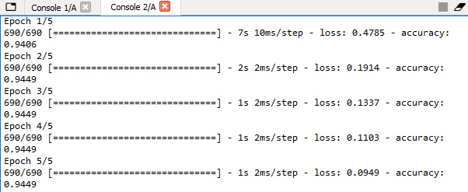

Fig 5.1 Output after SOM and ANN

Accuracy: After training the network for 5 epochs, we get an accuracy of **94.49%.**



Fig 5.2 Output 1

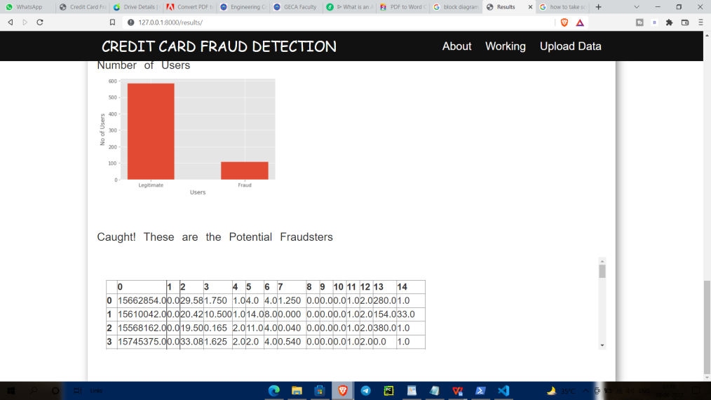

Fig 5.3 Output 2

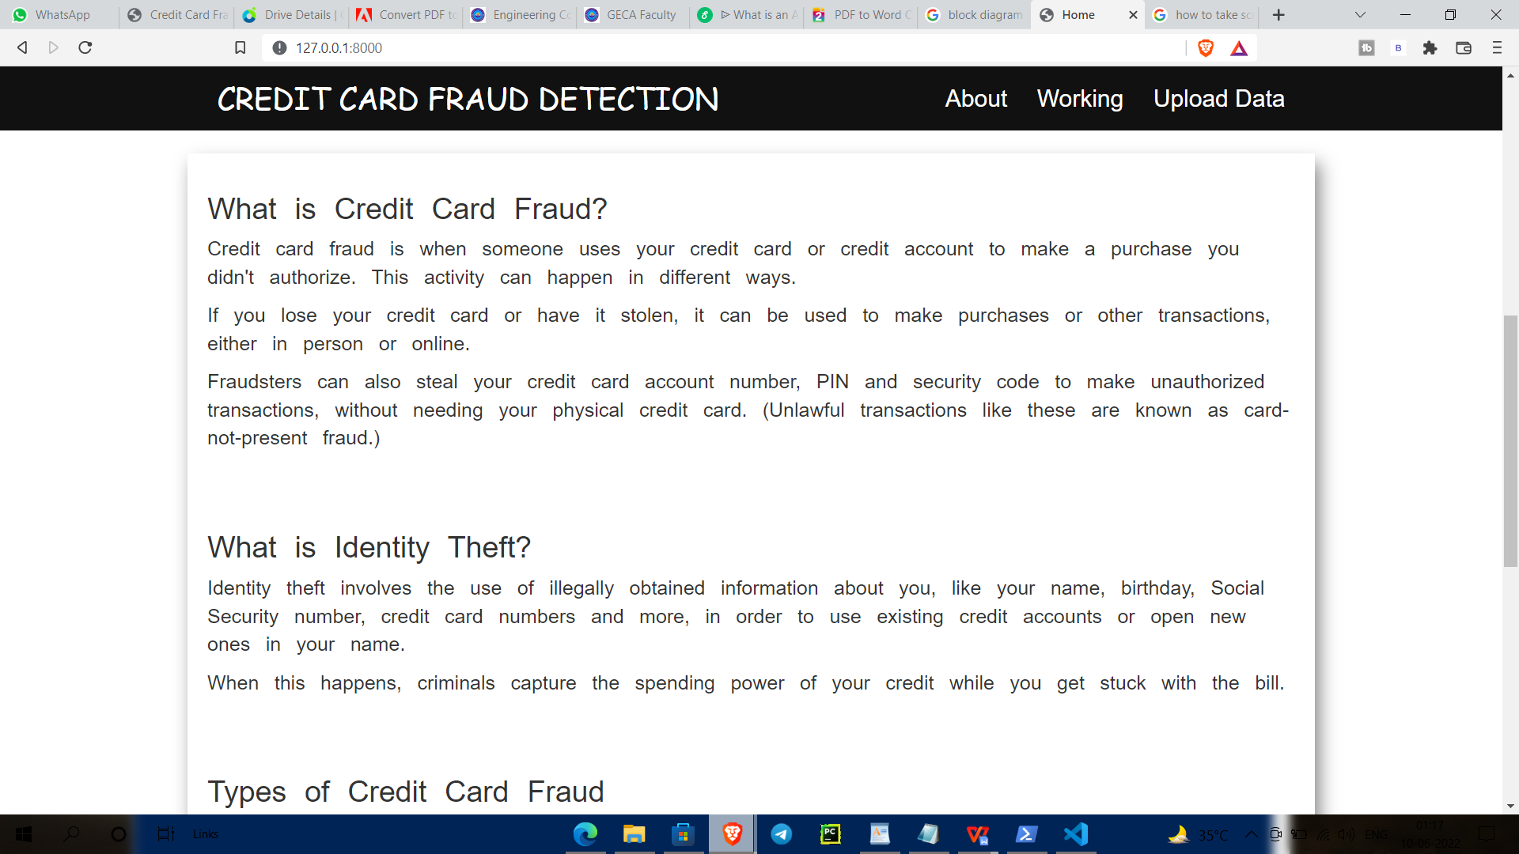Fig 5.4 Output 3

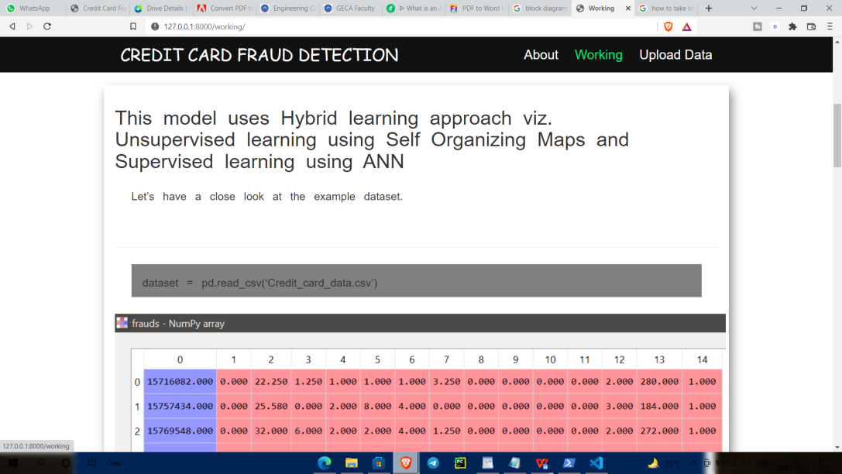

Fig 5.5 Output 4

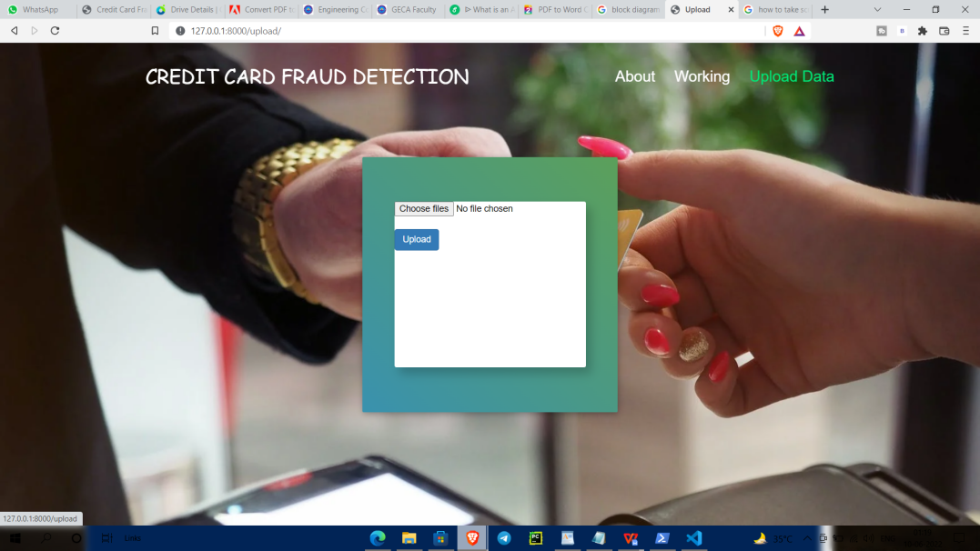

Fig 5.6 Output 5

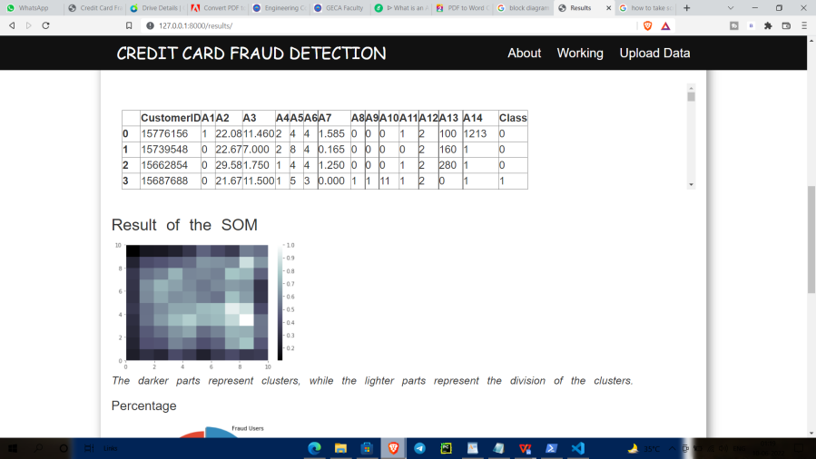

Fig 5.7 Output 6

**Chapter 6**

**Result Analysis & Discussion**

Our model achieved a accuracy of 94.49 % for fraud detection and the affected population (which were considered fraud but were not fraud was found to be 22.60 %. The results may vary if you run the same jupyter notebook because initialization of the weights of the nodes of SOM grid is done by randomly selecting the records/ patterns from the input space i.e. randomly selecting the records from the given dataset. Since, we have done training for 100 iterations and weights are randomly initialized every time, convergence may vary. We may try with different iterations like 100, 150, 200 etc. to have better convergence. You may also store the weights of the SOM for which you achieve better accuracy.

## Chapter 7

## Conclusion and Future Scope

**7.1 Conclusion:**

From the above comparative analysis of the various credit card fraud detection techniques it is clear that Artificial Neural Networks performs best in this scenario. But the drawbacks of Artificial Neural Networks is that they are very expensive to train and can be easily over trained. In order to minimize their expense we need to create a hybrid of neural network with some optimisation technique. Optimisation techniques that could be successfully paired with Neural Network are Genetic Algorithm, Artificial Immune System, Case Based Reasoning and any other similar optimisation technique.

**7.2 Future Scope:**

This model can be trained further so as to increase the accuracy of the system. It can be used for other data sets as well, with minor changes in the data pre-processing and wrangling. We can further increase the accuracy and performance of data-sets prediction either by increasing or decreasing data feature or features selection or applying feature engineering in our machine learning model.

## Appendix

## Real Dataset

The real dataset is highly imbalanced; 0.172% of all the transactions were fraudulent in nature. This dataset has 30 features. In the dataset, we are not provided with original features and background. We are provided with a PCA transformed version of the features due to confidentiality and privacy issues. This dataset has the following features: V1, V2, V3, …, V28 are PCA transformed for customer’s privacy issues. We have some other features that are not subjected to PCA transformation, such as ‘time’ and ‘amount’ [56].

Due to this dataset’s nature, we have applied several operations on this dataset to be able to use it properly. The following operations have been applied to the dataset:

1. Cleaning the Dataset:

First, we need to clean the dataset since it has many inappropriate and missing values in order to be able to use it to train our model. In general, this step involves deleting the rows that have missing or inappropriate values using RapidMiner studio [64].

1. Balancing the dataset:

Imbalance in a dataset is usually reflected by the asymmetrical distribution of classes within the dataset. For ease, we can call the class that makes up a massive proportion of the dataset as majority classes and the class that makes up a smaller proportion as minority classes [57]. We need to apply a sampling technique before performing a classification task on the imbalanced dataset. It is not easy to train a model with an imbalanced dataset.

21

We solved the problem of dealing with an imbalanced dataset by oversample the minority class. We have used RapidMiner Studio software [58] to balance our dataset.

In the feature space, RapidMiner studio selects close samples by drawing a boundary between the samples in the feature space and picking a new sample at any point along that line. Also, RapidMiner studio helped us to generate the data visualization [59].

1. Data analysis:

Our approach focuses on understanding the credit card transactions dataset and developing an effective model to detect fraudulent transactions. To better understand the dataset, we have performed exploratory data analysis (EDA) using widely used open- source libraries such as NumPy, Pandas, Matplotlib, and Seaborn using PyCharm community edition 2020.2 [65].

Matplotlib and Seaborn are excellent libraries for visualization in Python. We have obtained several visualizations such as histograms, bar graphs, density plots, and box plots using RapidMiner studio to get a better sense of the dataset.

For a better understanding of this dataset, see the following visualizations.

22

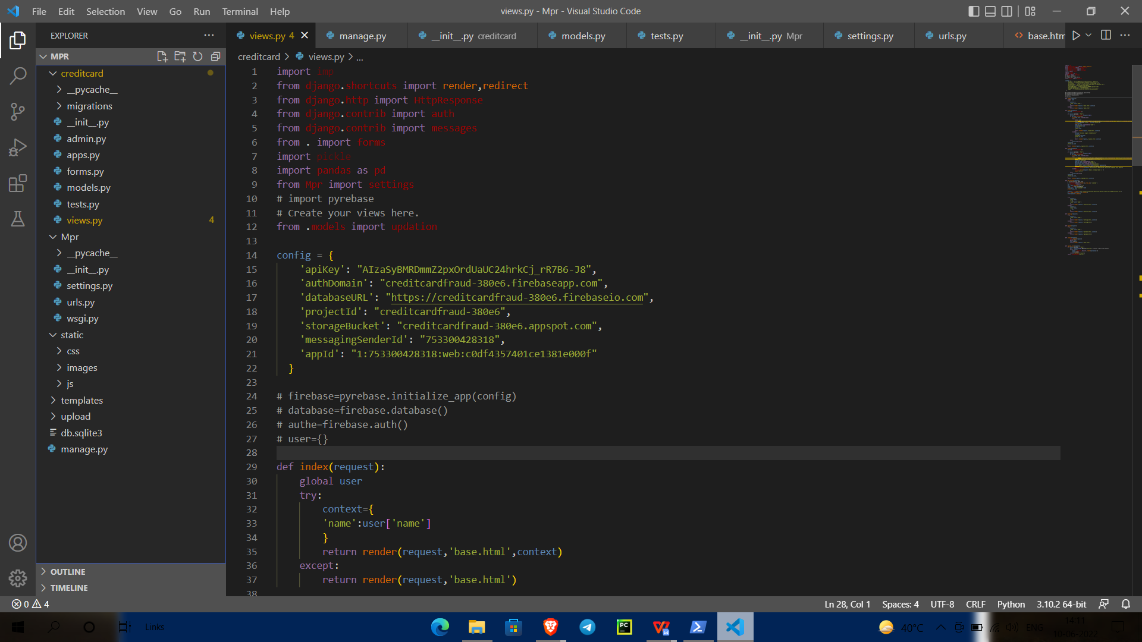

Appendix.1 codeing screenshot

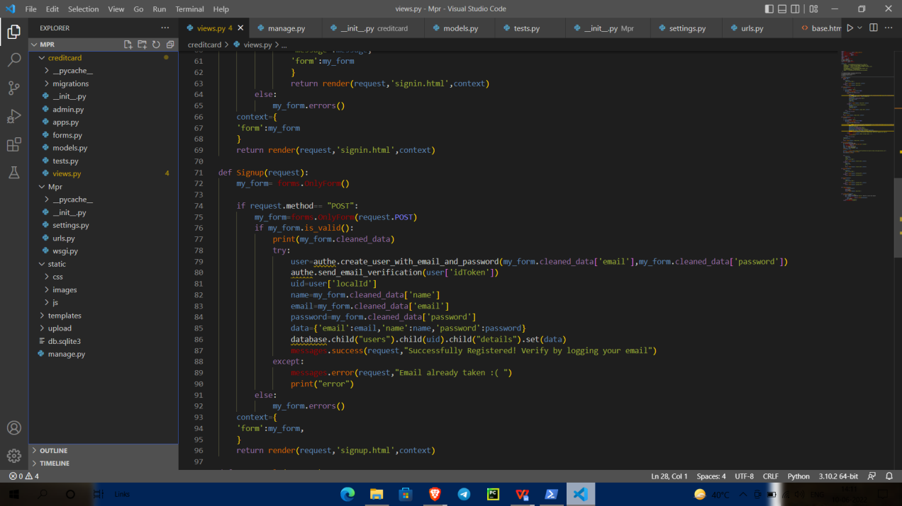

Appendix.2 codeing screenshot

## Bibliography

1. Dataset:

*[http://archive.ics.uci.edu/ml/datasets/Credit+Approval](http://archive.ics.uci.edu/ml/datasets/Credit%2BApproval)*

1. IEEE Technical Paper: htt[ps://www](http://www.researchgate.net/publication/334761474_Real-).re[searchgate.net/publicati](http://www.researchgate.net/publication/334761474_Real-)on[/334761474_Real-](http://www.researchgate.net/publication/334761474_Real-) time_Credit_Card_Fraud_Detection_Using_Machine_Learning [3]Book:

Linda Delamaire (UK), Hussein Abdou (UK), John Pointon (UK),” Credit card fraud and detection techniques: areview”, Banks and Bank Systems, Volume 4, Issue 2, 2009 [4]Website:

https://towardsdatascience.com/credit-card-fraud-detection-using-self-organizing- featuremaps-f6e8bca707bd

[5]Website:

https://rubikscode.net/2018/09/24/credit-card-fraud-detection-using-self-organizing-maps- and-python